This document is purposed to explain the automation test sample.

**Structure:**

The structure of the sample project likes the screen below:

The **TestBaseSetup.java** is defined browsers for web application.

The **Components package** included components which need to be tested in this sample project.

The **TestScripts package** included test scripts for the testing class which need to be executed by testing.xml

The **InputData.java** is for loading data from data folder, and using of those data for automation testing.

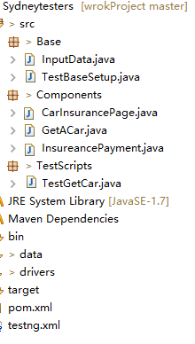

Execute the test class by testing.xml file as below:

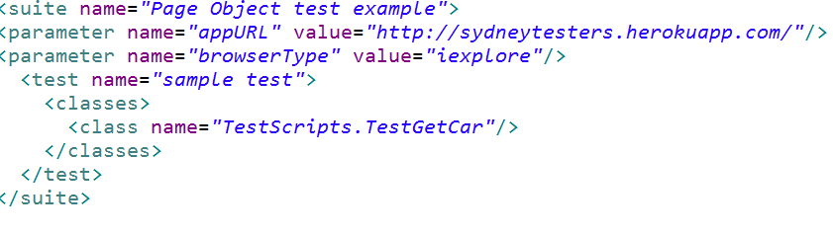

**Achieved test scenarios:**

1. Launch browser then go to <http://sydneytesters.herokuapp.com/> then click Get car quote button.
2. Get Car insurance page then verify attribute with text.
3. Click on Get quote button directly, and verify the error messages.
4. Enter relevant information and then click get quote button then verify the form is submitted.
5. Go to insurance payment page then verify attribute with text.
6. Click on Pay button directly, and then verify the error messages.
7. Enter the relevant information and then click on pay button.
8. Verify the payment is submitted successfully.

The test report will be created into test-output folder for reference.

**The list of things**

Below is the list of things which are commonly used in this sample:

1. Selenium webdriver with Java;
2. Mave build Tool
3. TestNG 6.8